Applications for extensions of legal assistance must be submitted electronically.
Select the appropriate Application template for the extension being sought.

Apply for extension

- Select Extension from the left hand menu under Applications.

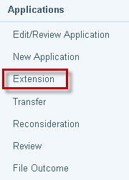

- The Search for File screen displays. Enter File ID and click on Search.

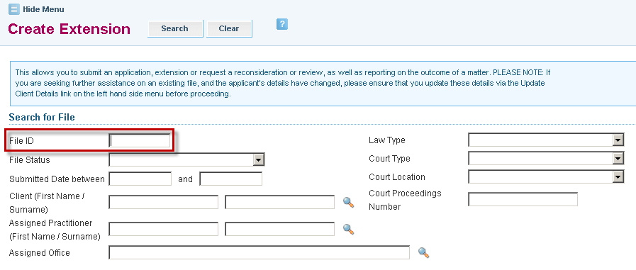

- Search results appear at the bottom of the screen. Click on the File ID link to retrieve the file.
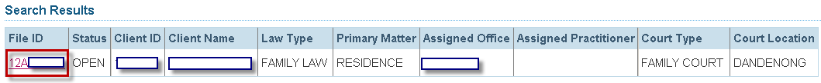

- Select the appropriate Application template for the extension being sought.
Also ensure that you select the relevant type of application:
- Simplified Process for section 29A panel practitioners
- VLA Assessed for section 30 panel practitioners
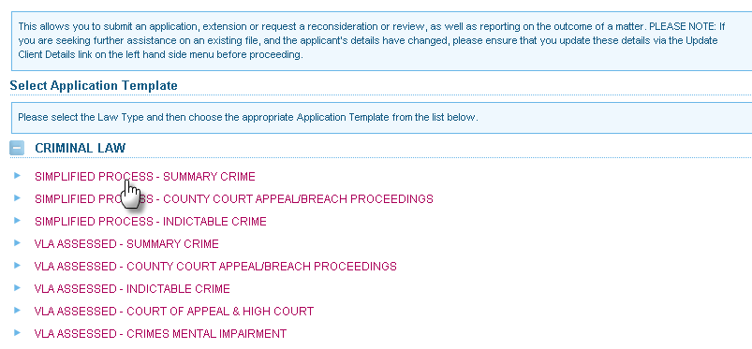

- If the incorrect template is selected, a message displays to notify that “You have selected an inappropriate template”. You will not be able to proceed further to lodge an extension. Return to Step 1.

- If the correct template is selected, an extension form is displayed.
The Extension number stays as 0 while it is in Draft status. It will change when the extension is submitted.
Use the extension number to retrieve and track the application.
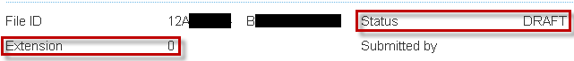

Note:
- The extension application remains in Draft Status until it is submitted.
- Extensions can be partially completed and the Draft can be saved at any time by selecting Save at the top of the screen.
- A message at the top of screen will confirm the draft extension has been saved successfully.

- The Applicant Details are displayed. Check and update the information, if required, in the following tabs: –
- Personal Details
- Additional Details
- FAP / Dependants
- Income
- Assets

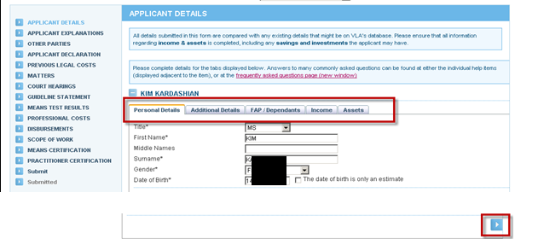
Use this arrow
to navigate through the Applicant Details tabs
OR
Click on the tab headers.

- Click the Next button to navigate to the next section of the application. At this point, the partly completed application will be saved automatically.
As a security measure, ATLAS ‘times out’ after 5 minutes of non activity.
To avoid loss of data, select Save at any time when entering client or application details.

- The sections of the application form are set out in the left hand menu. The form is interactive and certain questions are required or omitted dependent on information provided in other sections.
- Completed sections are marked with a green tick ☑
- Incomplete sections are marked with a red cross
- Sections yet to be completed are marked with a blue arrow

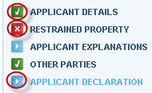

- If details of Other Parties were completed previously in the application for legal assistance, the details will be populated. Update if required. Select the Add button to add another party and complete their details.
If the Other Parties screen is selected in error, delete by clicking on theat the side of the screen and select Ok to the warning message.
To continue through to the next screen, select Next.

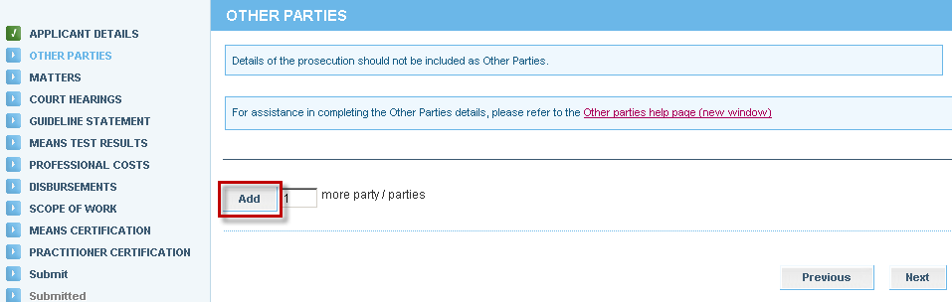

- The Matters screen will appear. It will contain Matters entered in the original application for aid. If the primary matter has changed, select the correct matter type.
Criminal law matters require the Plea to be selected for each Matter. Complete the CJEP/CAN field for each matter if available.

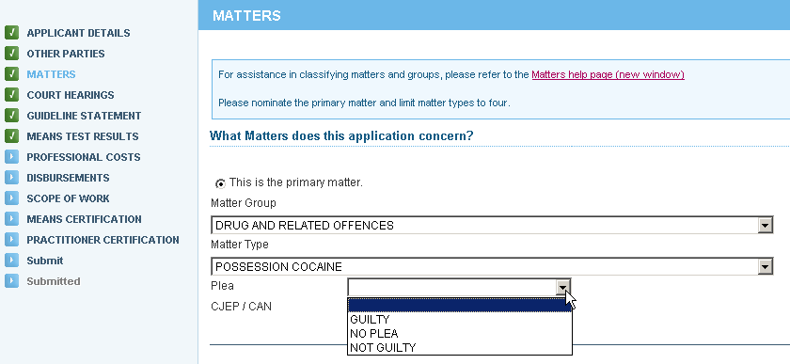

If an additional field is added in error, delete by clicking on the at the side of the non-required matters field and select Ok to the warning message. Select Next.

- In Family law matters, it is mandatory to complete details relating to the children, family dispute resolution, family violence orders and safety fears.

- Complete the Court Hearings screen, and select Next.

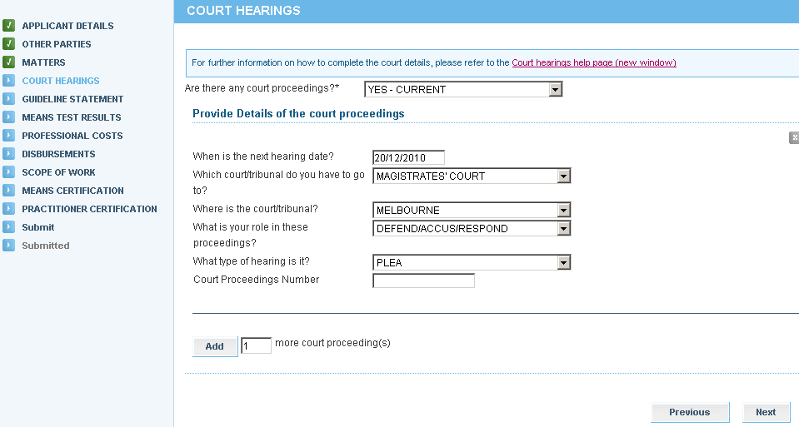

- The Guideline Statement screen will display. Choose the appropriate Guideline and select Next.

- Simplified Process for section 29A panel practitioners – select the appropriate guideline for the primary matter from the drop down list
- VLA Assessed for section 30 panel practitioners – complete all mandatory questions to address the guideline, merits, background and cost benefit/detriment of the matter

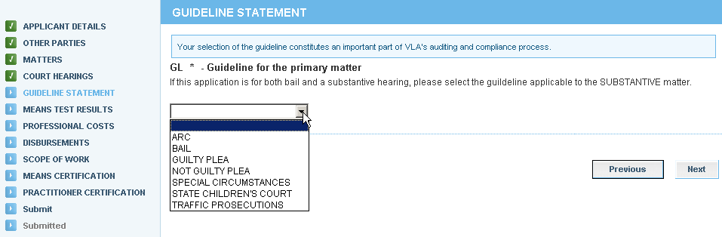

- The Means Test Results screen will appear: The results are based on the information entered for the client. Select Next.
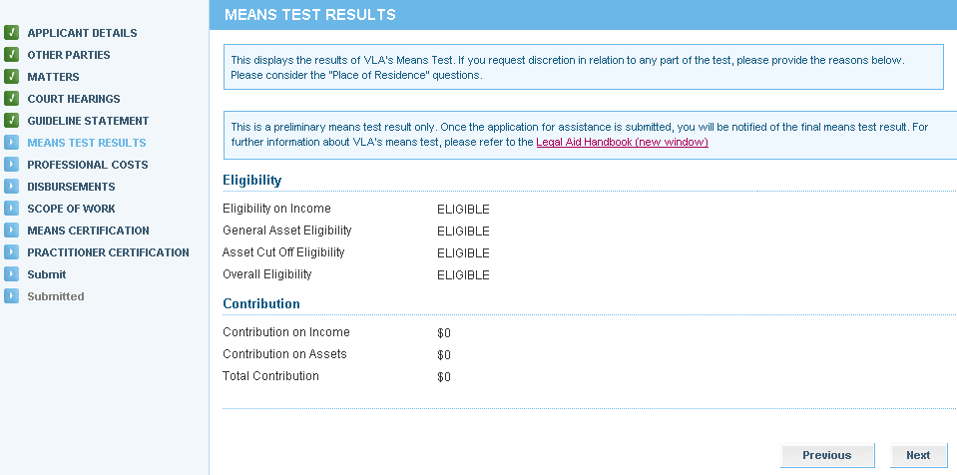

- The Professional Costs screen will appear. Select the extension of aid sought and select Next.

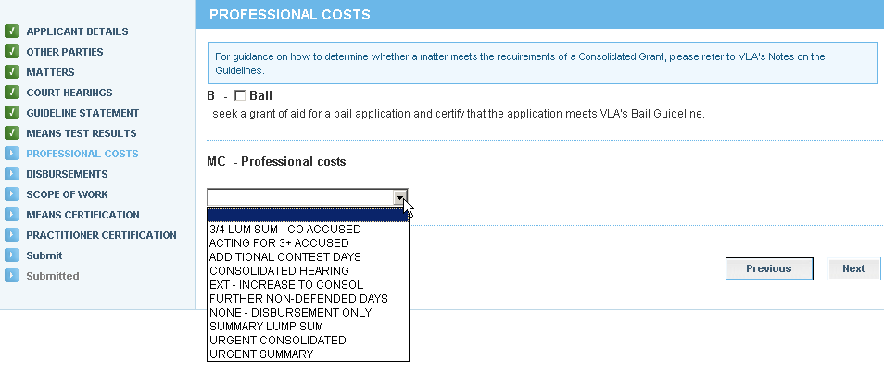

- The Disbursements screen will display. Select disbursements required, if any, and select Next.

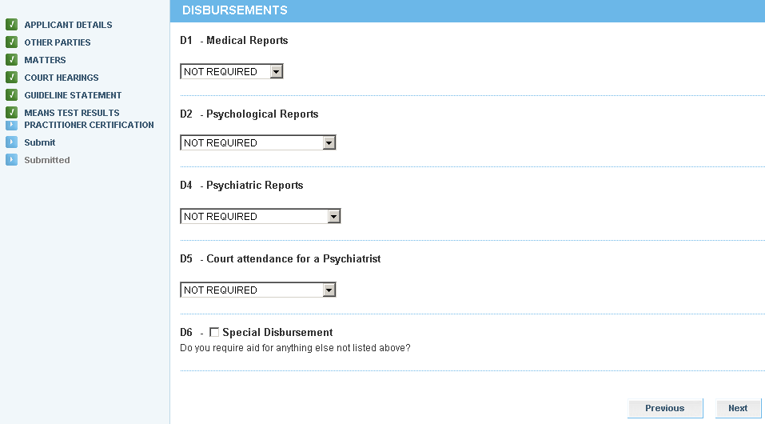

- The Scope of Work screen will display. This is a summary of the extension that has been requested. Review the details and select:
- Next to continue through the application
- Previous to amend any part of the application

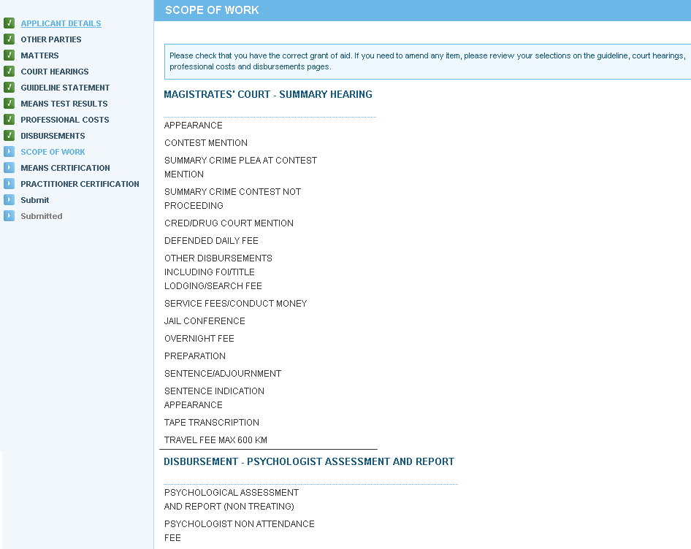

- The Means Certification screen will display. Select the appropriate certification and select Next.
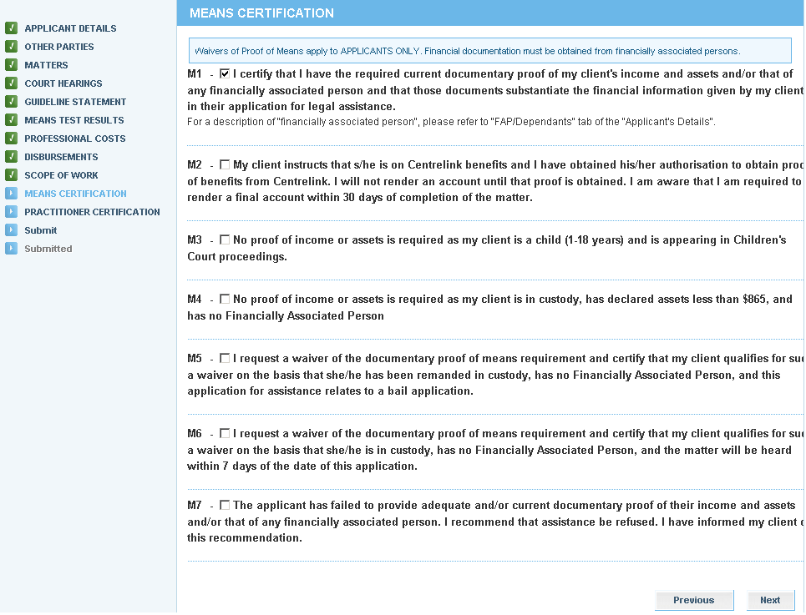

- The Practitioner Certification screen will display. The practitioner certifies that the extension application satisfies the applicable guidelines and merits tests. Complete the required fields and then select Next to proceed:
Do not use symbols in any Reference field to avoid a systems error. Symbols are not compatible in ATLAS, for example:

. , / - + ( * ) ! @ # $ % ^ & _ *

- Practitioner’s name (if not pre-populated)
- Date
- Practitioner’s Reference

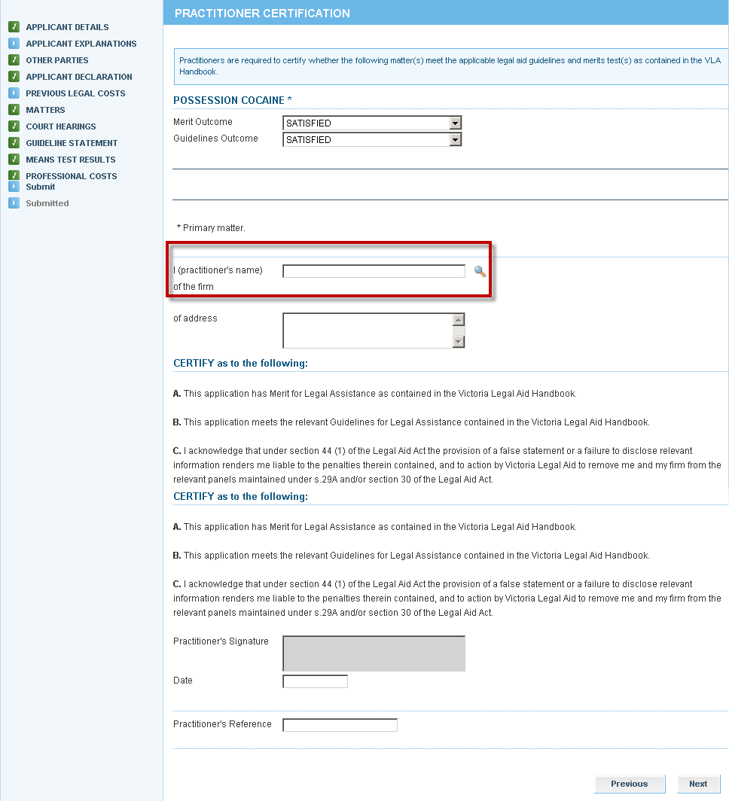

- The Submit screen will display. If the extension application is not ready for to be submitted, select Save to retain it as a draft or partially completed extension. Select Submit to send it to Victoria Legal Aid for processing.

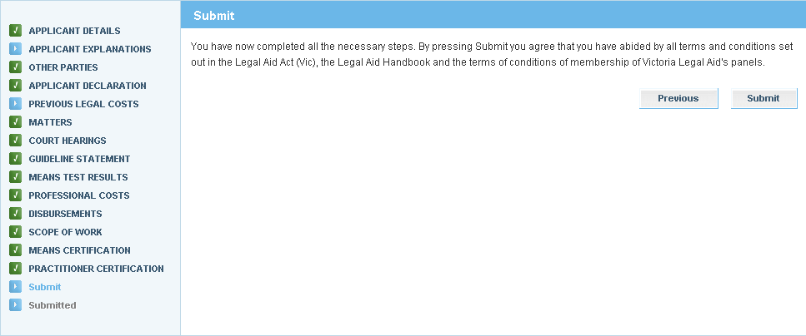
You can select
from the top menu if you want to submit at a later stage.

- The Attach Supporting Documents screen displays. If you do not have any attachments, click Continue to proceed. To attach a document, click on Show File Upload Area.

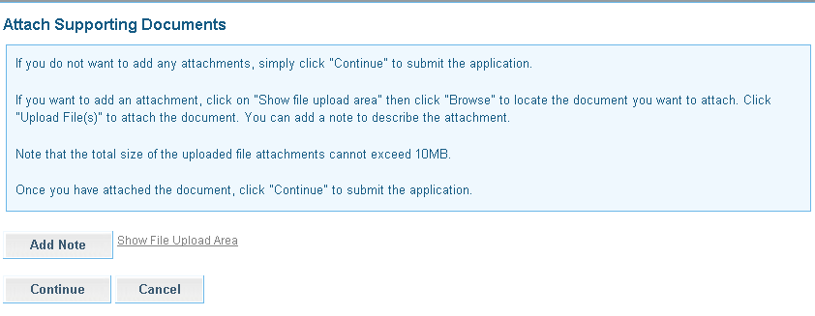

- The File Upload area will display. Click Browse and the Choose File dialogue box appears. Locate the file or document you wish to attach, click on Open to select it. The title of the selected document will populate in the field.
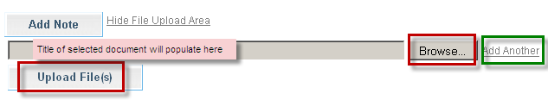

- Click Add Another if there are additional documents to be attached.

- Select Upload File.

- The File/Note Attachment grid will display with the relevant document(s).
To delete your attachment (if incorrectly attached) click the icon in the Action column.
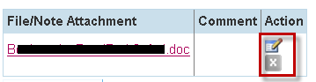

- To add or edit a Comment to describe the attachment, click the icon in the Action column.
Enter the comment, then click to save the comment. Click to delete the comment.

ATLAS has a 10 MB limit on the size of file attachments.

To avoid an error, split large attachments into two or more parts before attaching.

- To add a Note only, click Add Note.
Enter your Note and click to save the note or comment.
Click to delete the note or comment.

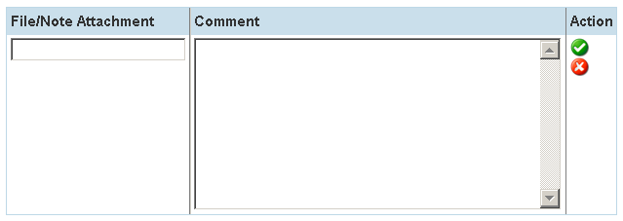

- Click Continue to submit the application. A message will display to confirm the application has been submitted successfully. The Extension number is noted at the top of the screen

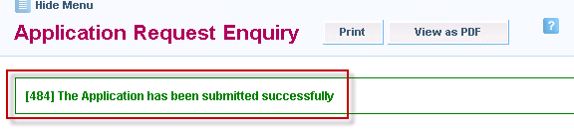
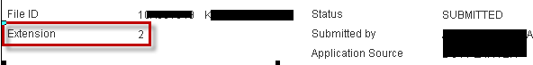

- Click either the Print or View as PDF button as required.



- A pdf copy of the extension application that has been submitted will be sent to your Inbox.

