Practitioners must report on the outcome of a case when the file is completed and there are no further claims to be submitted.

Use either the ‘File Outcome’ function or the ‘Record File Outcome’ link in Submit New Claim to report on the outcome.

File Outcome

- Either select File Outcome from the menu on the left hand panel, under Applications OR use the Record File Outcome link in Submit Claim.

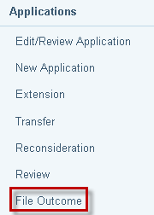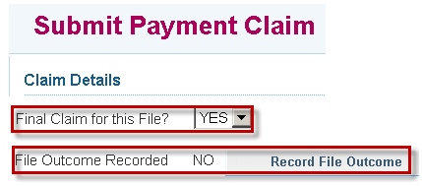

- The Search for File screen displays. Enter File ID and click on Search.
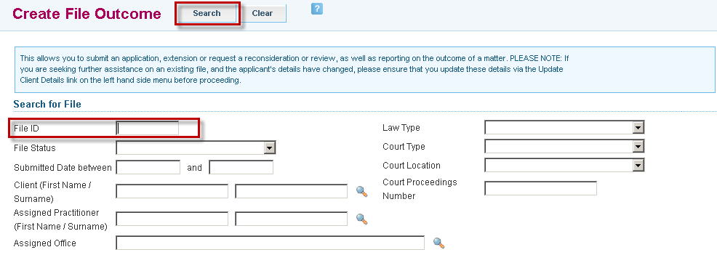

- Search results appear at the bottom of the screen. Click on the File ID link to retrieve the file.

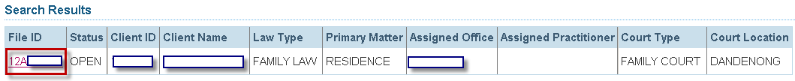

- The File Outcome fields displayed will depend on the law type of the file.

Criminal law matters require the relevant Hearing Type(s) to be selected.

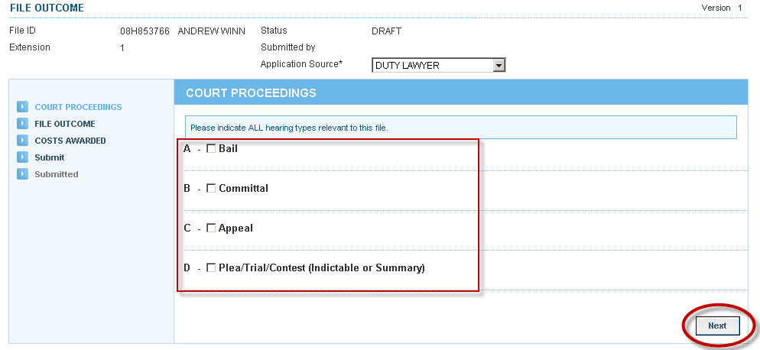

- Complete all required fields and click Next.

Criminal Law screen:
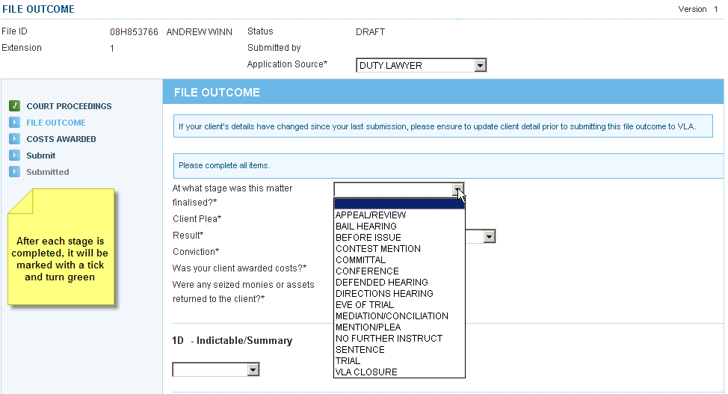

Family and Civil Law screen:
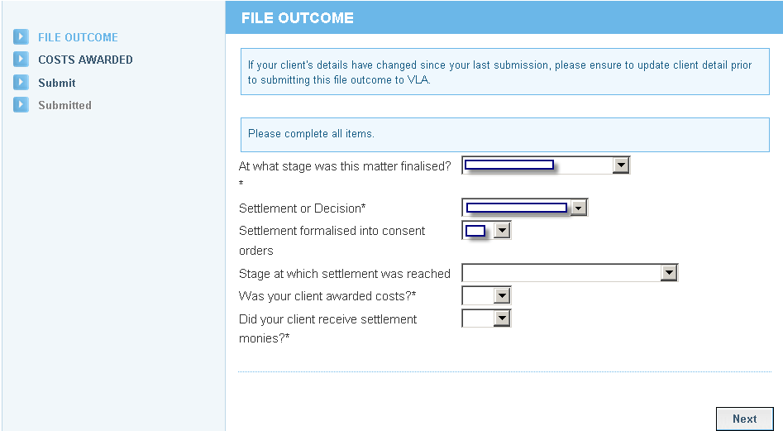

- Complete the Costs Awarded section, if applicable.

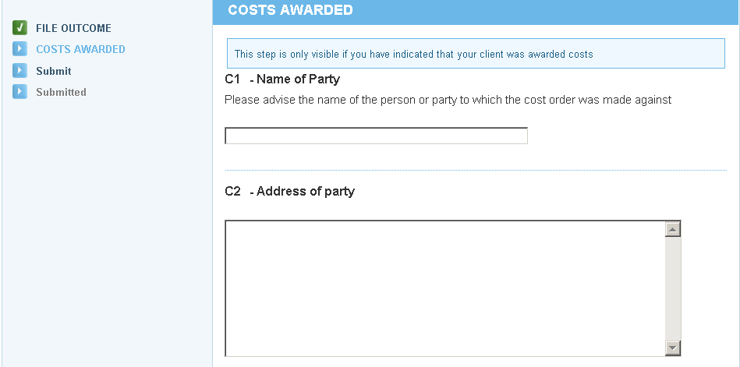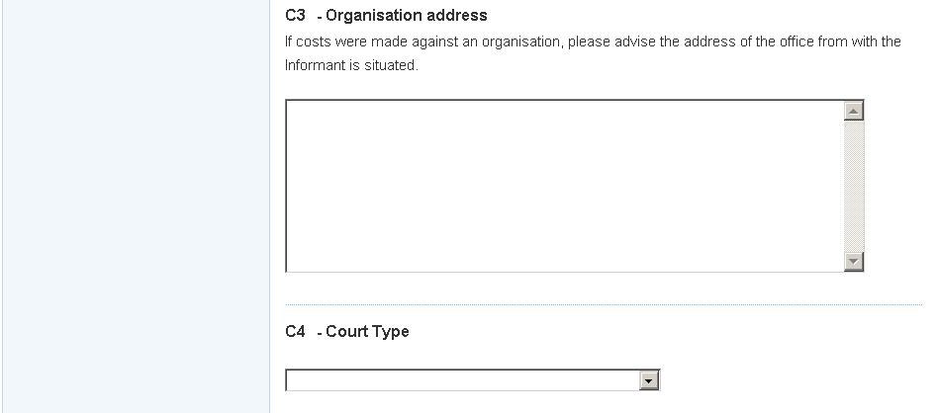
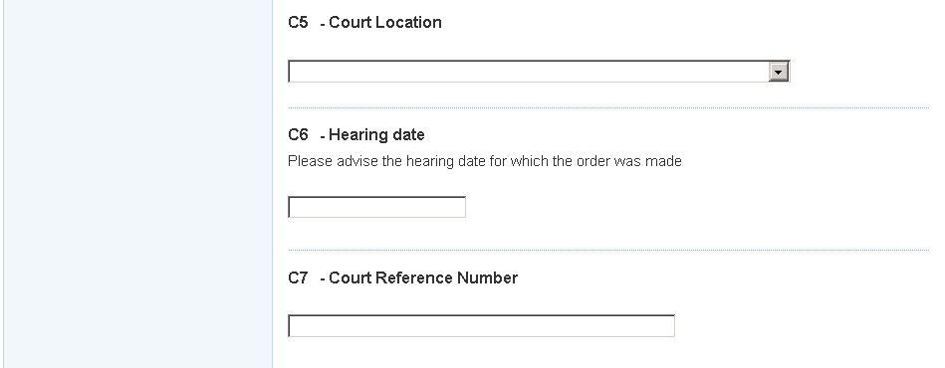
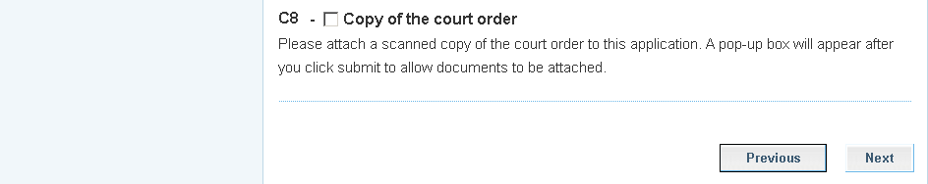

- Click Previous to amend information on a previous screen or click Submit.

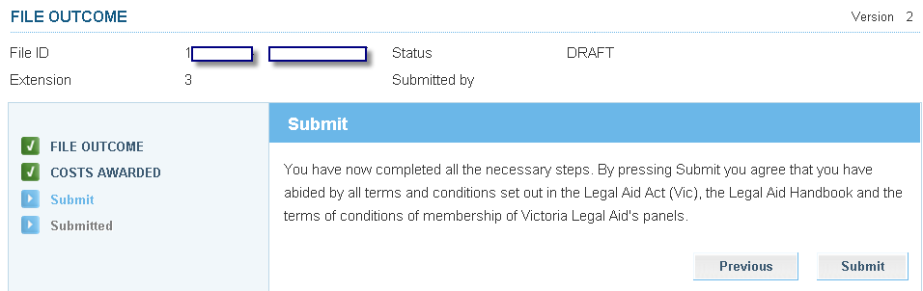

- The Attach Supporting Documents screen displays. If you do not have any attachments, click Continue to proceed. To attach a document, click on Show File Upload Area.

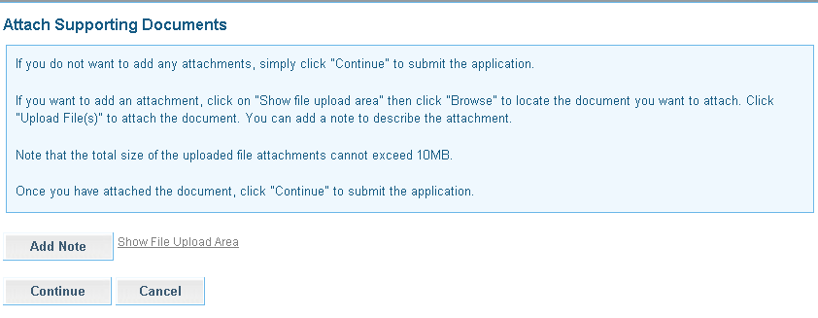

- The File Upload area will display. Click Browse and the Choose File dialogue box appears. Locate the file or document you wish to attach, click on Open to select it. The title of the selected document will populate in the field.
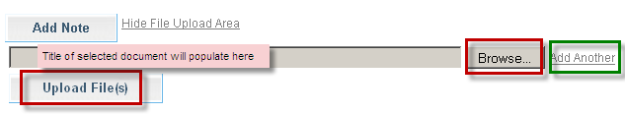

- Click Add Another if there are additional documents to be attached.

- Select Upload File.

- The File/Note Attachment grid will display with the relevant document(s).
To delete your attachment (if incorrectly attached) click the icon in the Action column.
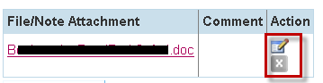

- To add or edit a Comment to describe the attachment, click the icon in the Action column.
Enter the comment, then click to save the comment. Click to delete the comment.

ATLAS has a 10 MB limit on the size of file attachments.

To avoid an error, split large attachments into two or more parts before attaching.

- To add a Note only, click Add Note.
Enter your Note and click to save the note or comment.
Click to delete the note or comment.

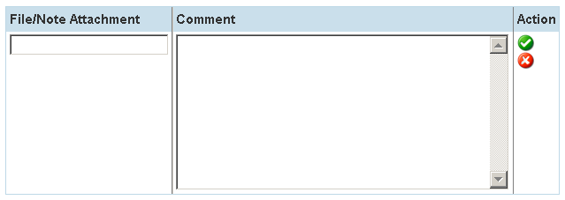

- Click Continue to submit the application. A message will display to confirm the application has been submitted successfully.

