Practitioners are required to submit all applications for legal assistance electronically using ATLAS. Members of the public may send a completed paper application form directly to Victoria Legal Aid, but this will not be accepted for applications submitted through a legal practitioner.
Practitioners are reminded that signed application forms are declarations and therefore applicants must only sign the form once it is complete.
Practitioners must ensure that the applicant:
- Completes and signs a paper application, details of which are to be entered into ATLAS; or
- Signs a printed copy of a completed ATLAS application
The completed application signed by the client must be retained on the file. Note that the applicant declaration page alone is not sufficient.

Submit New Application

- Select New Application from the left hand menu, under Applications.
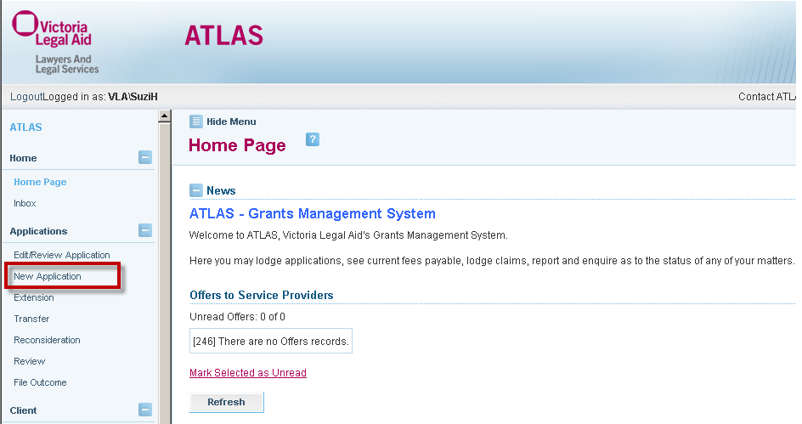

- Select Law Type.
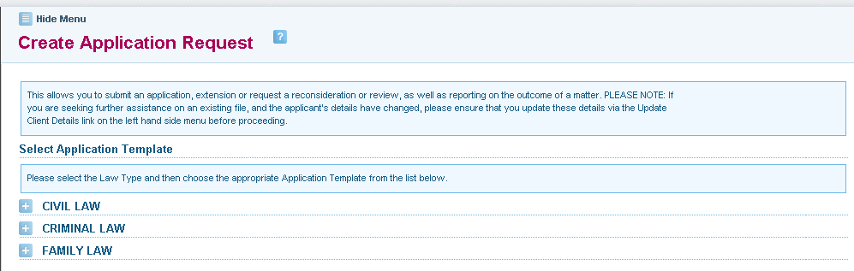

Application templates or forms will appear under each law type:
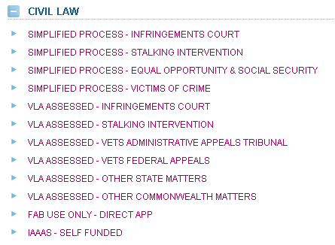
Tip
Infringement Court applications are funded under VLA’s civil law guidelines.
Refer to the Civil Law templates.

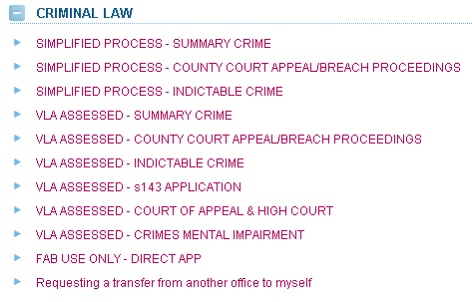

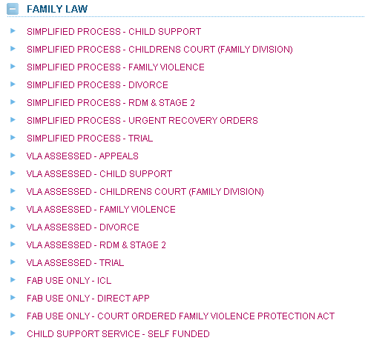

- Select the Application Template required.
Select the relevant type of application:
- Simplified Process for section 29A panel practitioners
- VLA Assessed for section 30 panel practitioners
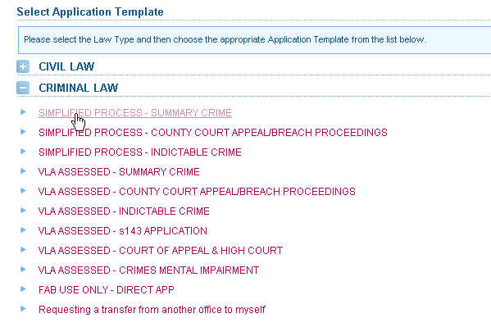
- The Search for Client screen will display. Enter the client’s details and click on Search.

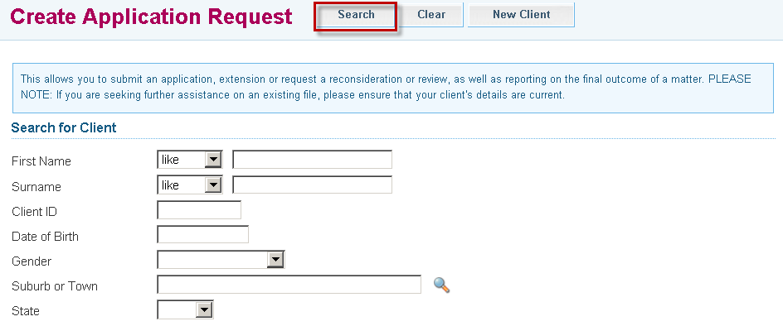

- Search results are returned at the bottom of the screen. Click on the client’s name to retrieve the client’s details.

- Matching results
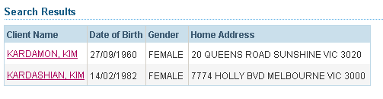
Only the names of current clients belonging to your firm will appear. Past clients will not be displayed.

- If no client record is found, you will need to create a new client in ATLAS



- Select New Client at the top of the screen.


- An application form is displayed. A File ID is automatically assigned to the application. Use this number to retrieve and track the application. This file number will not be saved if the application is cancelled.

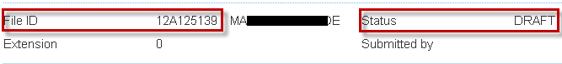

- The application remains in Draft Status until it is submitted. Applications can be partially completed and the Draft can be saved at any time by selecting Save at the top of the screen. A message at the top of screen will confirm the draft application has been saved successfully.

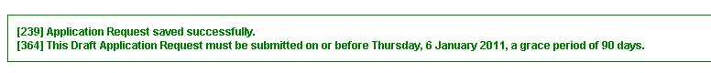
Note:
- Victoria Legal Aid can only process an application that is submitted
- Draft or saved applications cannot be processed
- Draft applications are deleted from ATLAS after 90 days

- Complete the relevant fields within the Applicant Details tabs: –
- Personal Details
- Additional Details
- FAP / Dependants
- Income
- Assets
Tip

Use this arrow
to navigate through the Applicant Details tabs.

OR

Click on the tab headers.
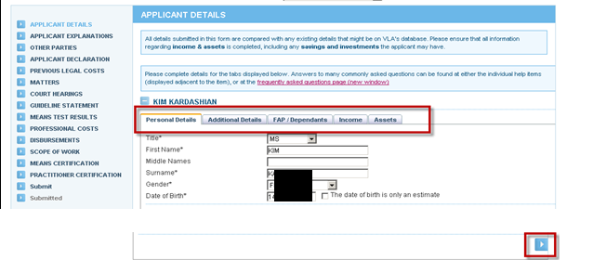
Use this arrow
to navigate through the Applicant Details tabs
OR
Click on the tab headers.

- To enter or edit an address, click Edit.
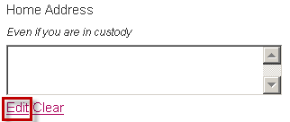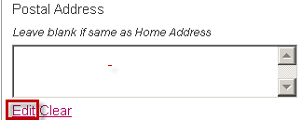

- The Address Details screen displays. Select the appropriate address format and street type from the drop down lists.
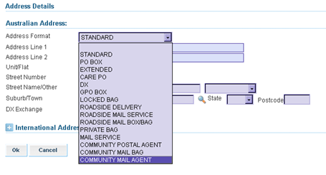

- Enter the suburb and postcode. If you do not know it, click on the pick list (magnifying glass icon). The Select a Suburb/Town search screen displays. Enter the suburb and click Search. Click on the correct option to continue.

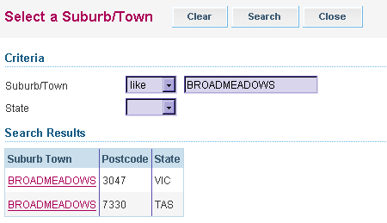

- Click the Next button to navigate to the next section of the application. At this point, the partly completed application will be saved automatically.
As a security measure, ATLAS ‘times out’ after 5 minutes of non activity.
To avoid loss of data, select Save at any time when entering client or application details.

- The sections of the application form are set out in the left hand menu. The form is interactive and certain questions are required or omitted dependent on information provided in other sections.
- Completed sections are marked with a green tick ☑
- Incomplete sections are marked with a red cross
- Sections yet to be completed are marked with a blue arrow

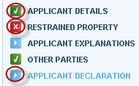

- Complete the Other Parties screen, if required. Select the Add button to add another party and complete their details. If Other Parties screen is selected in error, delete by clicking on theat the side of the screen and select Ok to the warning message. To continue through to the next screen, select Next.

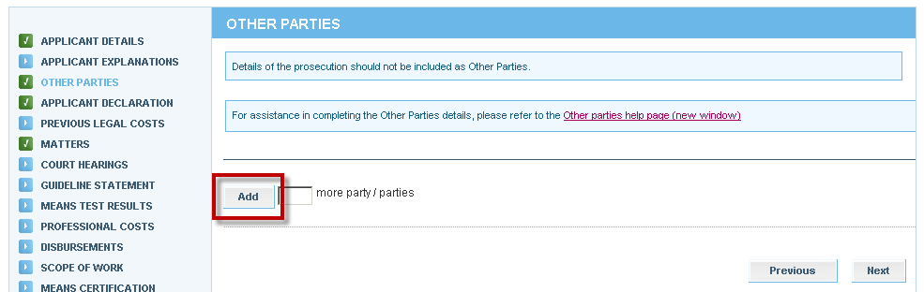

- The Applicant Declaration screen displays. Complete questions and enter the date the client signed the application and then select Next.

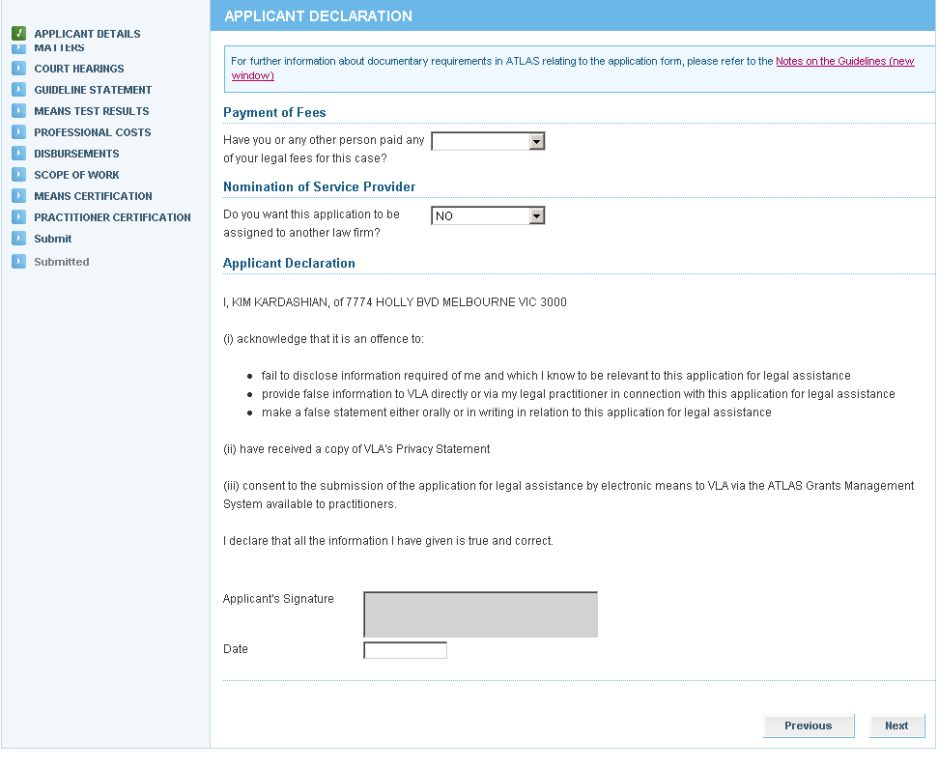
The electronic copy is unsigned; however a complete copy of the application signed by the Applicant must be retained on the file.

- The Matters screen displays. Add matters by clicking on the drop down arrow to select the Matter Group, then clicking on the drop down arrow to select the appropriate Matter Type. Ensure the primary matter type is selected. The first matter entered will default to the primary matter. This can be changed by using the indicator –
When applying for RDM for parenting issues and property, practitioners must always place parenting issues as the primary matter.

To add multiple matters either:
- Click on Add, or
- Enter the number of matters to be added, and then click on Add

If an additional field is added in error, delete by clicking on the at the side of the non-required matters field and select Ok to the warning message. Select Next.

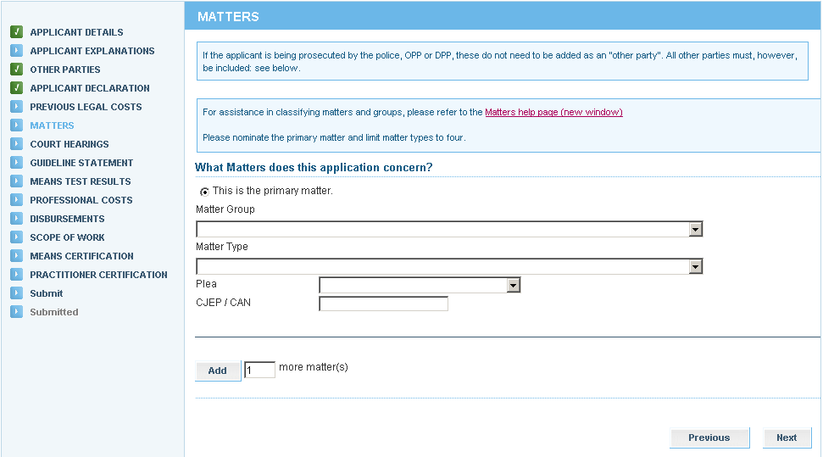

Criminal law matters require the Plea to be selected for each Matter. Complete the CJEP/CAN field for each matter if available.

- The Court Hearings screen will display. Complete and select Next.

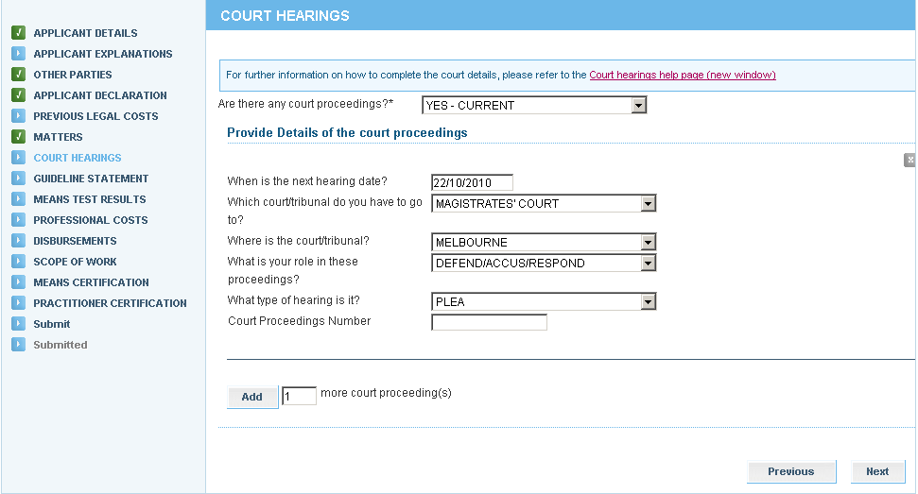

- The Guideline Statement screen will display. Choose the appropriate Guideline and select Next.

- Simplified Process for section 29A panel practitioners – select the appropriate guideline for the primary matter from the drop down list
- VLA Assessed for section 30 panel practitioners – complete all mandatory questions relating to the guideline, merits, background and cost benefit/detriment of the matter

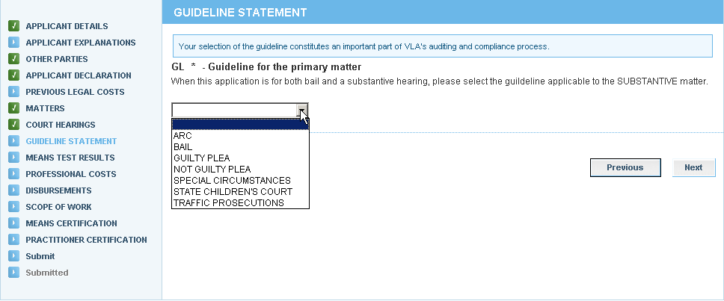

- The Means Test Results screen will display. The results are based on the information entered for the client. Select Next.
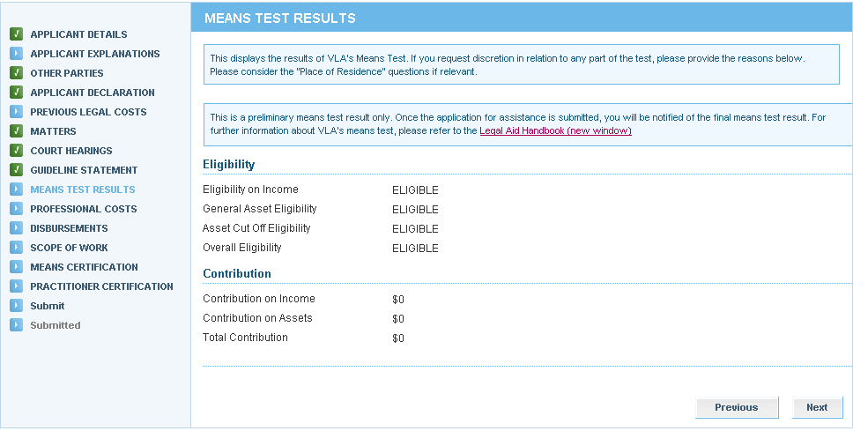

- The Professional Costs screen will display. Select the type of grant sought and select Next.

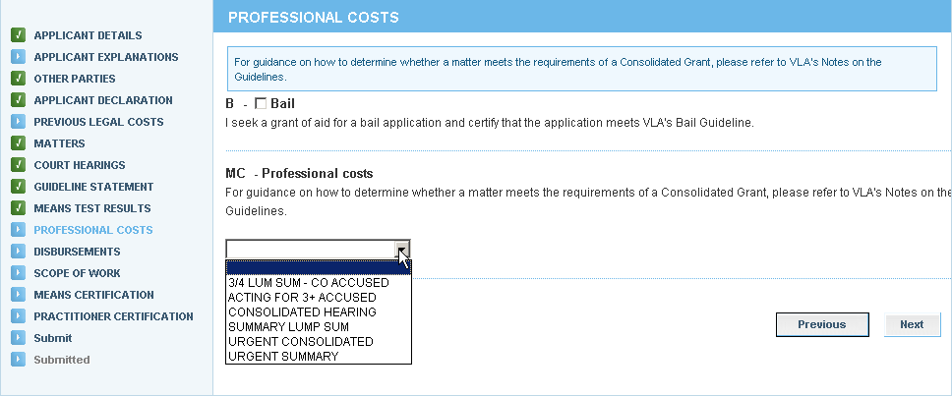

- The Disbursements screen will display. Select disbursements required, if any, and select Next.

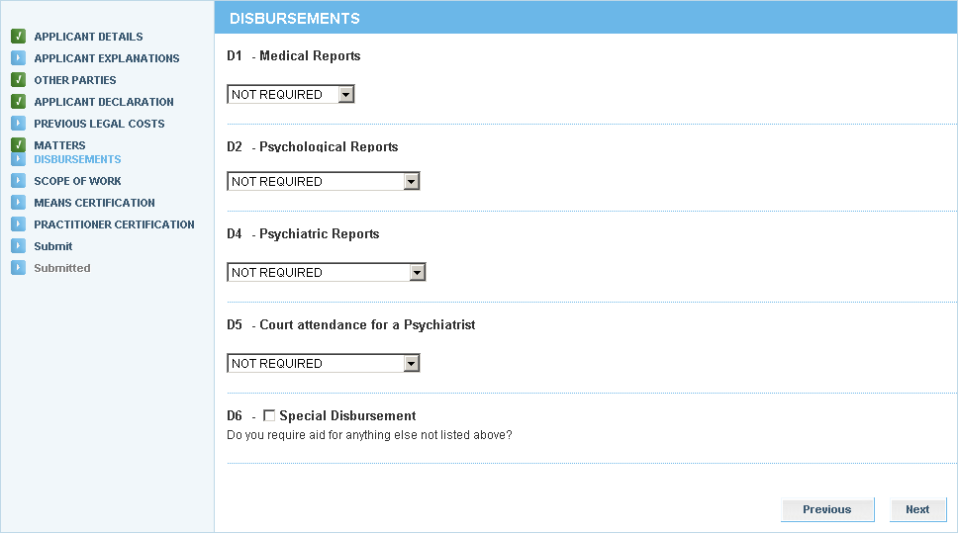

- The Scope of Work screen will display. This is a summary of the grant that has been requested. Review the details and select:
- Next to continue through the application
- Previous to amend any part of the application
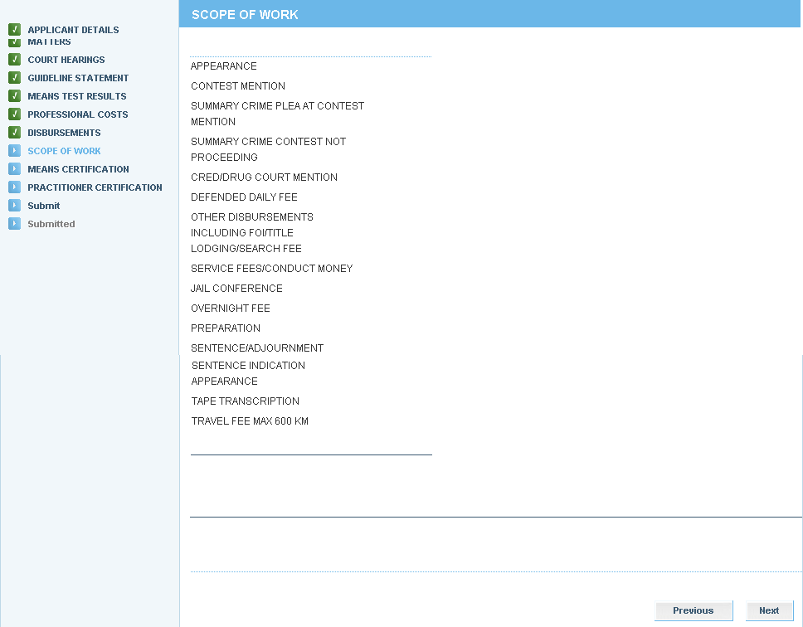

- The Means Certification screen will display. Select the appropriate certification and retain copies of proof of means on your file. Select Next.

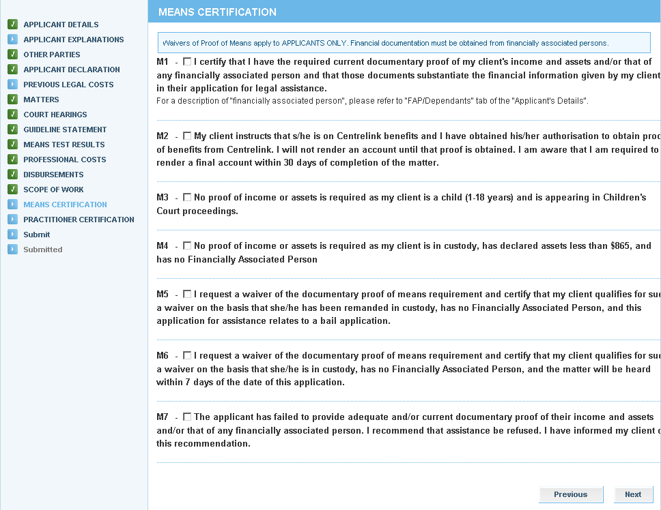

- The Practitioner Certification screen will display. The practitioner certifies that the application satisfies the applicable guidelines and merits tests. Complete the following fields and then select Next to proceed:
- Practitioner’s name (if not pre-populated)
Do not use symbols in any Reference field to avoid a systems error. Symbols are not compatible in ATLAS, for example:

. , / - + ( * ) ! @ # $ % ^ & _ *

- Date
- Practitioner’s Reference

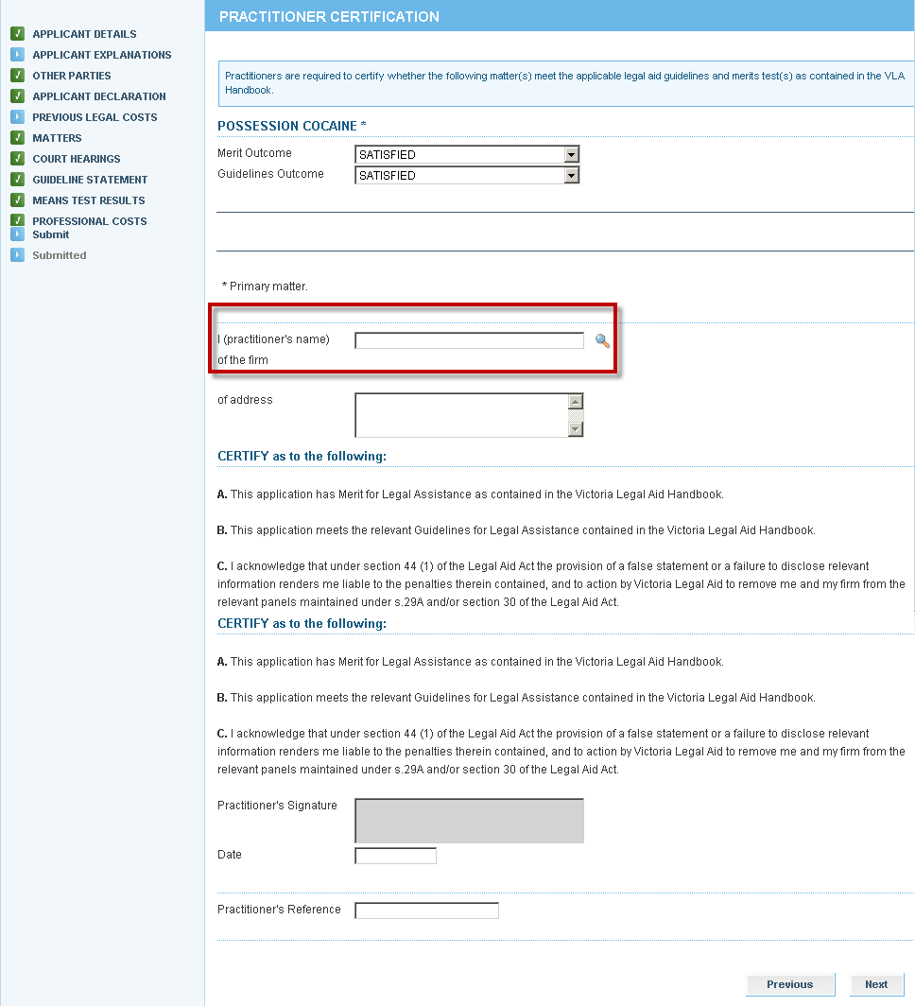

- The Submit screen will display. If the application is not ready for to be submitted, select Save to retain it as a draft or partially completed application. If required, Print a copy to be signed by the client. Select Submit to send it to Victoria Legal Aid for processing.

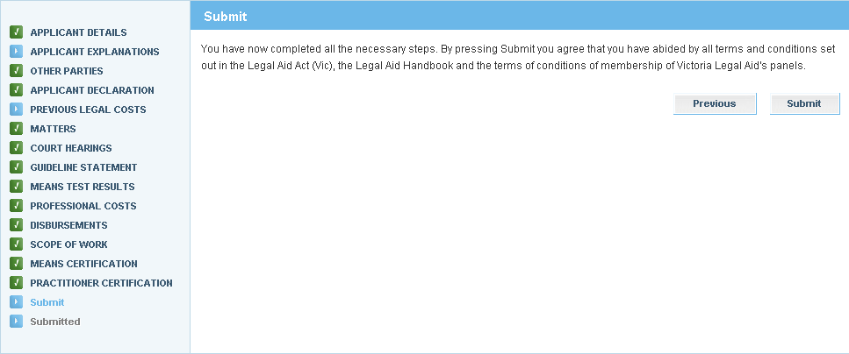
You can select
from the top menu if you want to submit at a later stage.

You can print a copy to be signed by the client prior to submitting.

- A message will display to confirm the application has been submitted successfully.

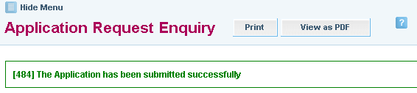
- A pdf copy of the application that has been submitted will be sent to your Inbox.

