Invoice
Invoices are assigned upon approval of a grant of legal assistance or an extension and contain work items that can be claimed such as:
- preparation fees
- appearance fees
- standard or non-standard disbursements

Claim
Multiple claims can be made against an invoice for work items with multiple units such as additional hearing days. The amount claimed for each work item must be within the amount set out in the invoice.

Documentary proof
Practitioners must retain on file copies of documents relating to and substantiating disbursements (such as expert reports) and attendances for events (such as court appearances) that are paid by VLA.

Error in submitted claim
If you made an error on a submitted claim, use the ‘Submit Correspondence’ function in ATLAS to notify VLA of details of the adjustment required.

Submit New Claim

- Select Submit New Claim from the left hand menu.

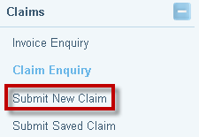

- The Search for a Proforma Invoice screen will display. Enter the File ID and click on Search to find the pro forma invoice.

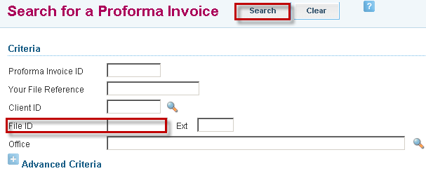

- Search results will be displayed. Click on the Invoice link to retrieve the file.

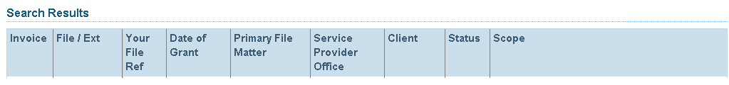

- The Submit Payment Claim screen will display.
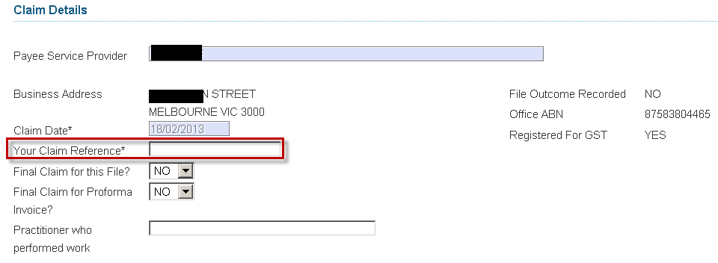
- Your Claim Reference is mandatory and needs to be a unique reference for each claim. if you will be submitting more than a single claim, add a letter or digit after your firm’s file reference to form the unique identifier for each claim, for example 90876SH1 and 90876SH2.
Do not use symbols in any Reference field to avoid a systems error. Symbols are not compatible in ATLAS, for example: . , / - + ( * ) ! @ # $ % ^ & _ *

- Final Claim for this File? Select Yes, if this is the last payment for the entire file and the file is to be finalised. No further claims will be able to be submitted.

Do not select Yes to Final Claim if the grant of assistance is being transferred from your office to another practitioner as it remains an ongoing ATLAS file.

- Click on Record File Outcome and refer to the File Outcome user guide to complete this screen, if applicable.

- Final Claim for Proforma? Select Yes, if this is the last payment for that invoice or extension
If unsure, do not select Yes to Final Claim or Proforma. Once a final claim for an invoice is certified, no further claims may be submitted against the invoice.

- Practitioner who performed work is not a mandatory field

- In the Work Items section, complete the following fields, if required: 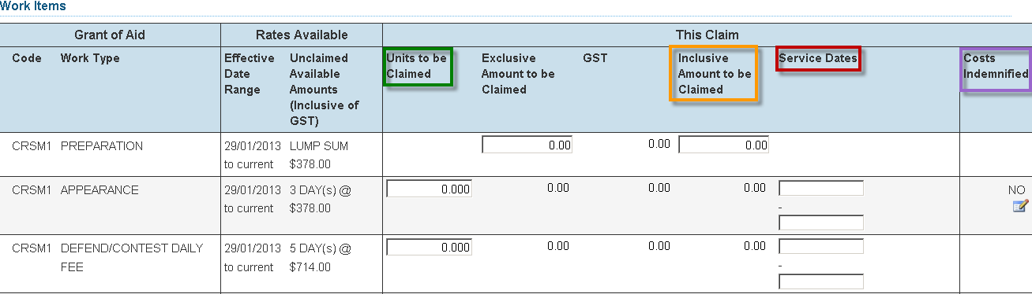

- Units are entered in the relevant Units to be Claimed field, where multiple days are available to claim against

- Work types that are not unit based (i.e. a Stage of Matter Limit) are entered as a $ value in the Inclusive Amount to be Claimed field. GST will be automatically calculated and the amount exclusive of GST will be automatically populated

- Service Dates are the dates of the court appearances and must be entered as start and end dates
  - If the appearance is for one day, the start and end dates are the same
  - If the appearance is for more than one day or for non consecutive days, enter the first and last day of service. You will need to manually override the end date populated by ATLAS

- Costs Indemnified or costs recovered (eg. if an Appeals Costs Fund (ACF) Certificate is issued in a matter), refer to the ‘Costs Indemnified’ user guide for help in completing this section

- The Certification statement will be automatically populated with the practitioner’s name. Select Save if not yet ready to submit for payment, or click Submit Claim to send to VLA to process for payment.

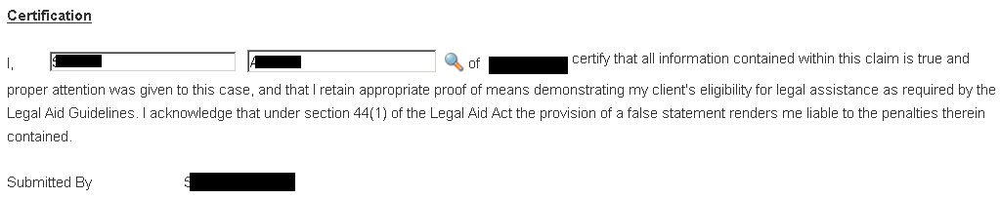
Invoices and documentary proof must be retained on the file for compliance and audit purposes

- A message will display to confirm the claim has been submitted successfully.
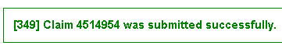

- A pdf copy of the claim that has been submitted will be sent to your Inbox.

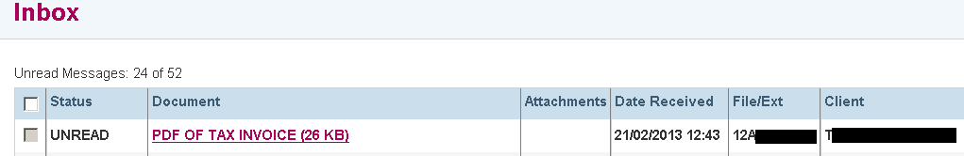
If an error has been made on a submitted claim, use the ‘Submit Correspondence’ function in ATLAS to notify VLA of details of the adjustment required. The claim will be adjusted by VLA. Claims cannot be increased, they can only be adjusted down.

