Submit a Reconsideration application to seek reconsideration of a decision or condition relating to a grant of assistance. Attach supporting documentation if required.

Apply for Reconsideration

- Select Reconsideration from the left hand menu under Applications.
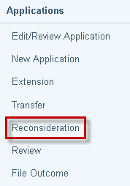

- The Search for File screen displays. Enter File ID and click Search.
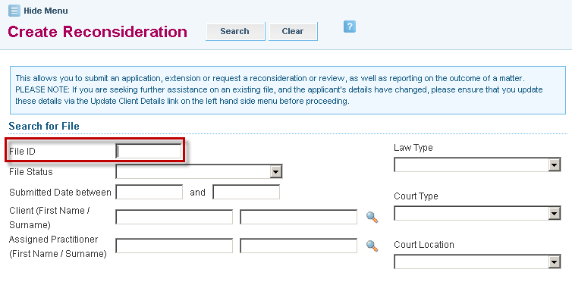

- Search results appear at the bottom of the screen. Select the File ID link.

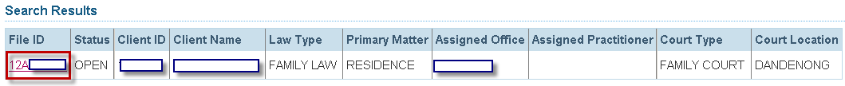

- The Request for Reconsideration screen will appear:
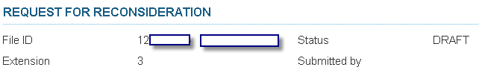

- Enter the Extension number for which you are seeking a reconsideration.
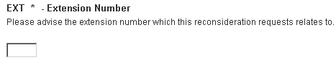
- Select one or more criteria on which the request for reconsideration is based and click Next to continue.
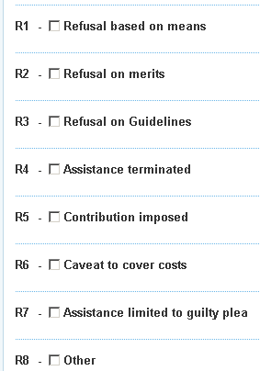

- Complete all screens that display.
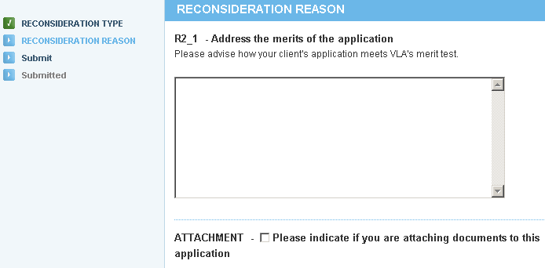

- Complete the Address the VLA Guideline relevant to the application box
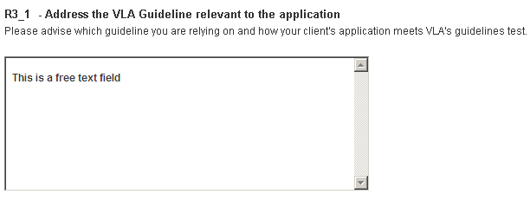

- Complete the Attachment indicator if attaching documents. Click to continue
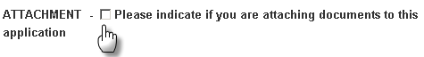

- The Submit screen will display. Click Submit to continue, or Previous to make any changes.

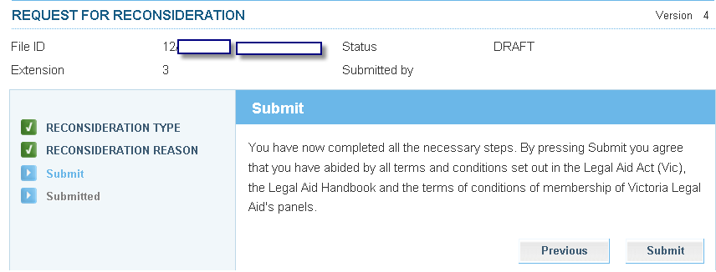

- The Attach Supporting Documents screen displays.
If you do not have any attachments, click Continue to proceed.
To attach a document, click on Show File Upload Area.

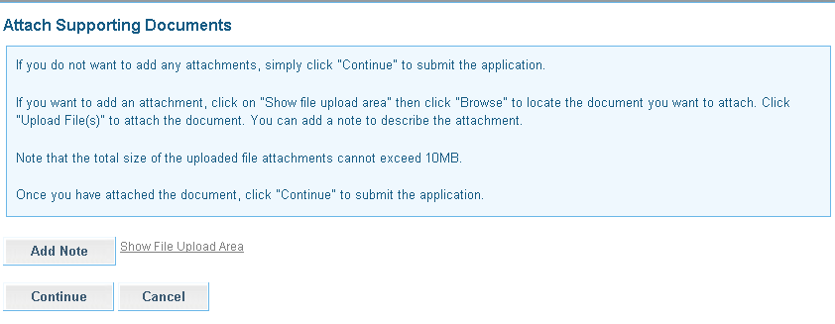

- The File Upload area will display. Click Browse and the Choose File dialogue box appears. Locate the file or document you wish to attach, click on Open to select it. The title of the selected document will populate in the field.
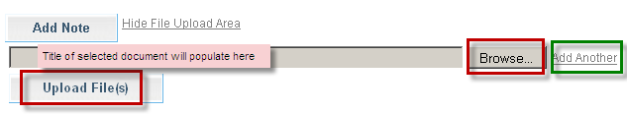

- Click Add Another if there are additional documents to be attached.

- Select Upload File.

- The File/Note Attachment grid will display with the relevant document(s).
To delete your attachment (if incorrectly attached) click the icon in the Action column.

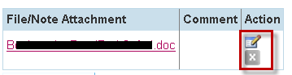

- To add or edit a Comment to describe the attachment, click the icon in the Action column.
Enter the comment, then click to save the comment. Click to delete the comment.

ATLAS has a 10 MB limit on the size of file attachments.

To avoid an error, split large attachments into two or more parts before attaching.

- To add a Note only, click Add Note.
Enter your Note and click to save the note or comment.
Click to delete the note or comment.
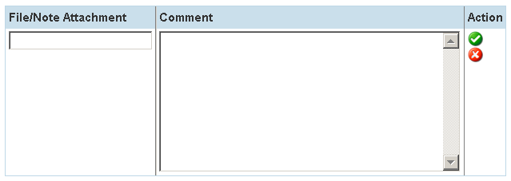

- Click to submit the application. A message will display to confirm the application has been submitted successfully.
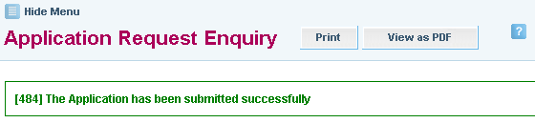

- Click either the Print or View as PDF button as required.



- A pdf copy of the application that has been submitted will be sent to your Inbox.

