Claims can be saved and returned to at a later stage for further action.
Saved claims are able to be:
- retrieved
- updated
- submitted
- deleted

Saved Claim

- Select Submit Saved Claim from the left hand menu.

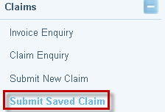

- The Search for a Claim screen will display. Enter the File ID and click on Search to find the saved claim.

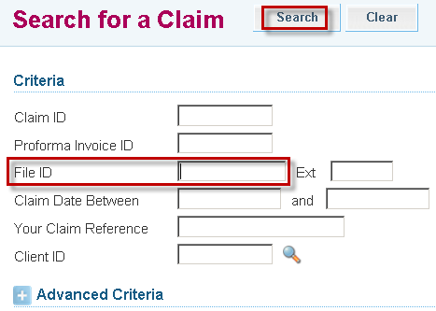

- The Submit Saved Claim screen will display.

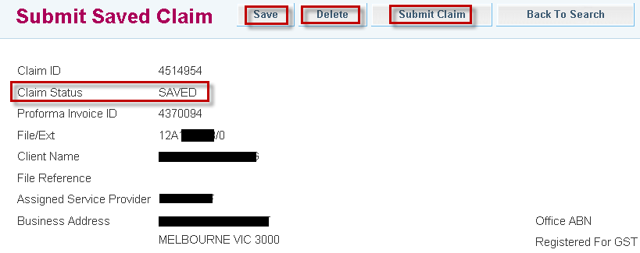

- Select Delete if you no longer require this claim.

- Alternatively, complete the relevant Claim and Work Item details, then select Submit Claim to send the invoice to VLA to process for payment.

- If you are not yet ready to submit this claim, select Save.

